**Wireshark Lab 2 – HTTP**

**CHIBUNZE UZO**

1. My browser is running on HTTP version 1.1

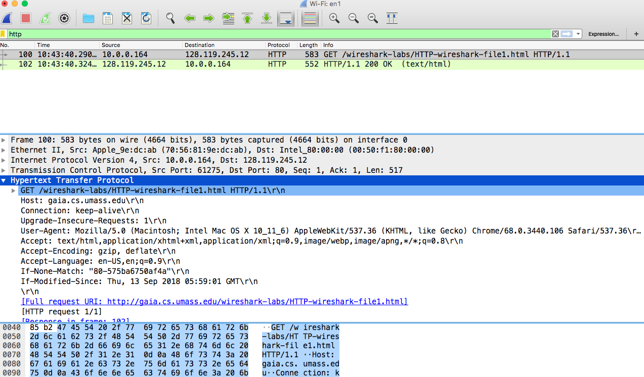

1. The HTML file was last modified on Fri, 14 Sep 2018 05:59:01

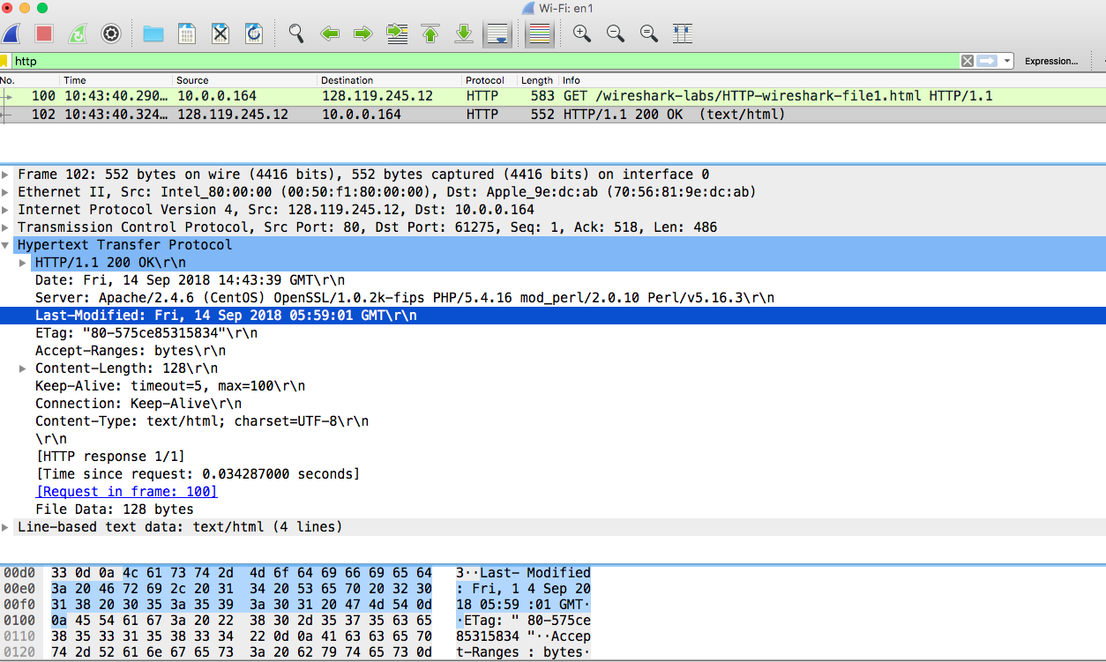

1. The IP address of my computer is 10.0.0.164 while that of the gaia.cs.umass.edu is 128.119.245.12

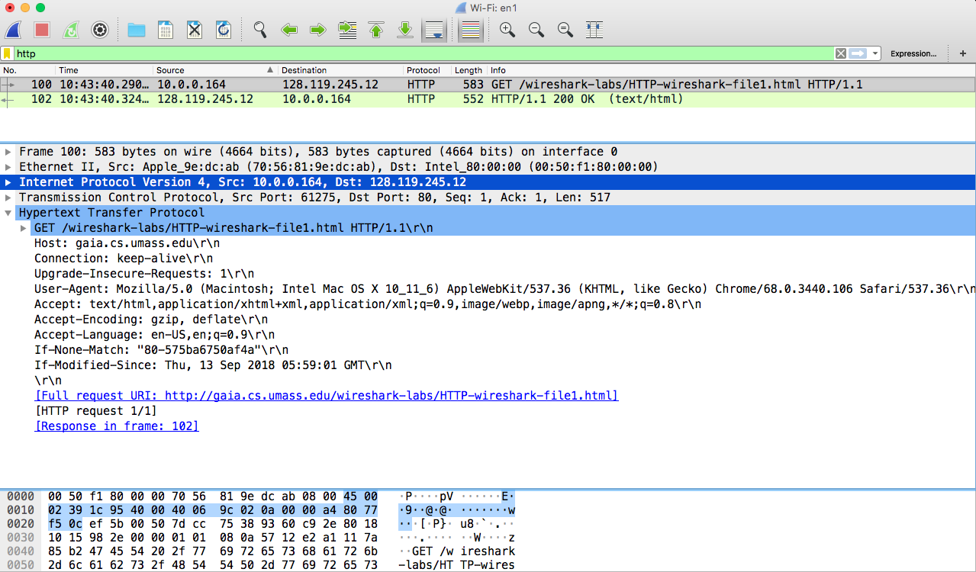

1. The language my browser indicated that the server accepts is English Language.

